BJP5 Self-Check 1.10: Shaq

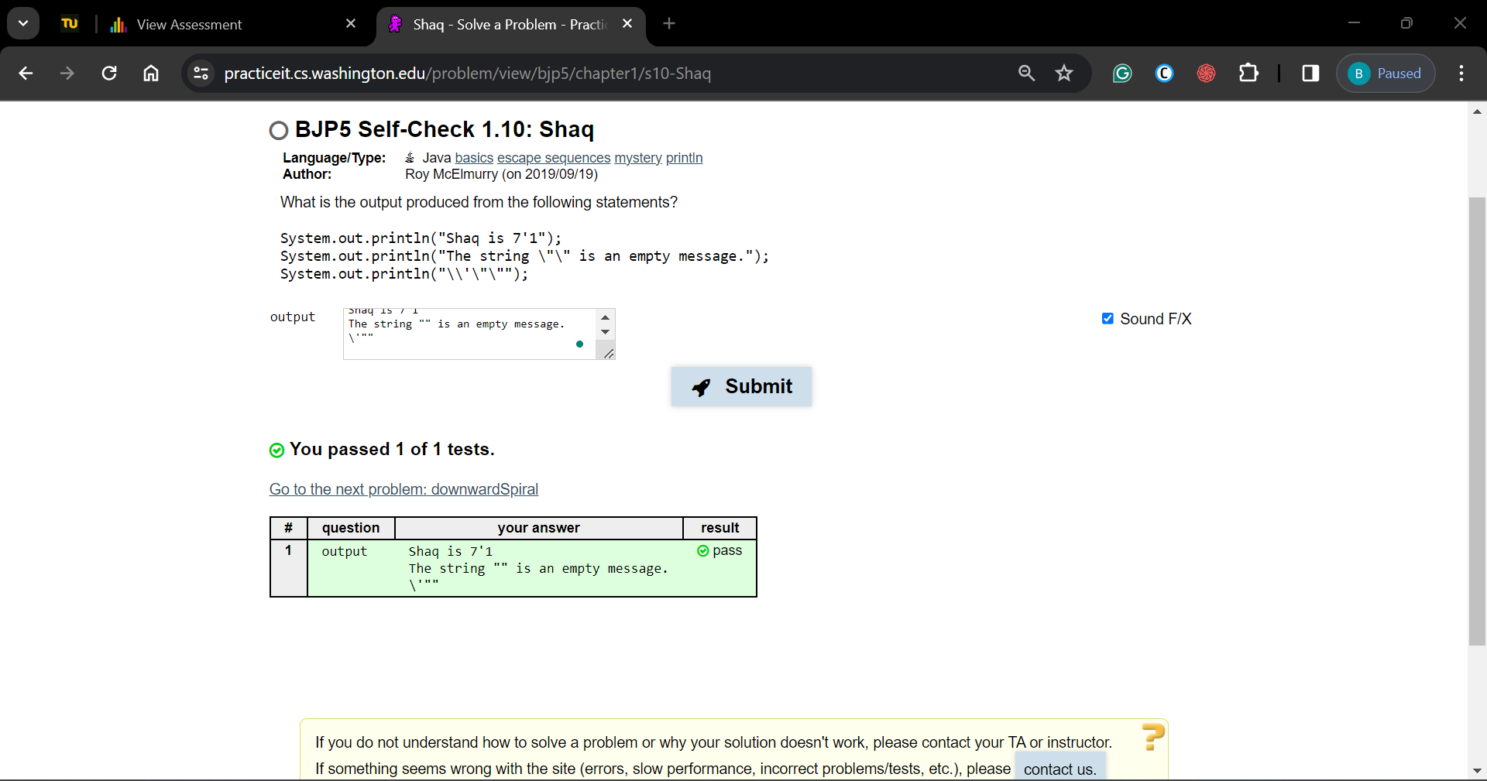

BJP5 Self-Check 1.20: FamousSpeech-errors

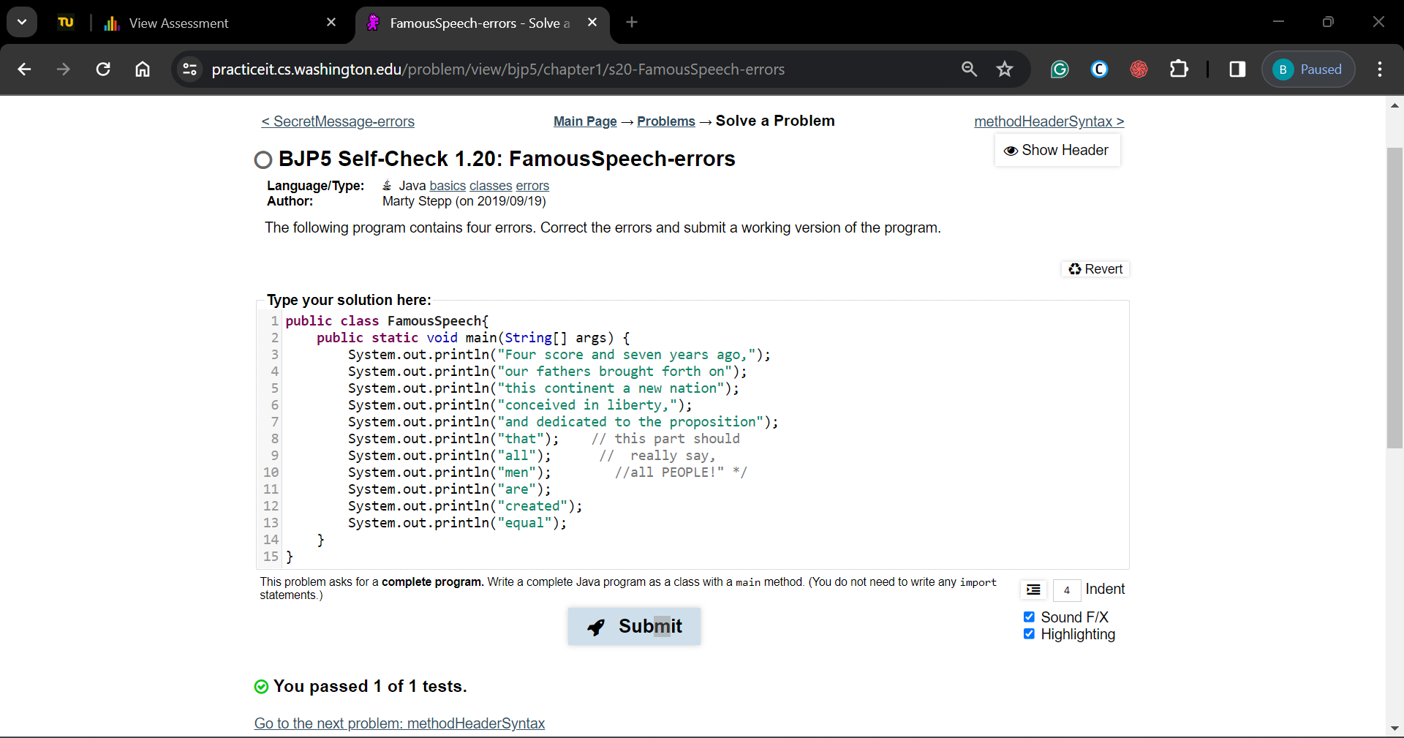

BJP5 **Exercise 1.5**: MuchBetter

public class MuchBetter {

    public static void main(String[] args) {

        System.out.println("A \"quoted\" String is");

        System.out.println("'much' better if you learn");

        System.out.println("the rules of \"escape sequences.\"");

        System.out.println("Also, \"\" represents an empty String.");

        System.out.println("Don't forget: use \\\" instead of \" !");

        System.out.println("'' is not the same as \"");

    }

}

BJP5 **Exercise 1.8:** Stewie2

public class Stewie2{

    public static void Print_Victory(){

        System.out.println("|| Victory is mine! ||");

        System.out.println("\\\\\\\\\\\\\\\\\\\\\\\\\\\\\\\\\\\\\\\\\\\\");

    }

    public static void main(String[] args){

        System.out.println("//////////////////////");

        for (int i =0;i<5;i++)

            Print_Victory();

    }

}

BJP5 Self-Check 2.5: expressions3

